**Tumor Detection from Brain MRI Images**

**Problem Statement**

Healthcare sector is totally different from other industry. It is on high priority sector and people expect highest level of care and services regardless of cost. After the success of deep learning in other real-world application, it is also providing exciting solutions with good accuracy for medical imaging and is a key method for future applications in health sector. Brain is an organ that controls activities of all the parts of the body. Recognition of automated brain tumor in Magnetic resonance imaging (MRI) is a difficult task due to complexity of size and location variability. In this research statistical analysis morphological and thresholding techniques are proposed to process the images obtained by MRI for Tumor Detection from Brain MRI Images. Feed-forward backprop neural network will be used to classify the performance of tumors part of the image. The results produced by this approach will increase the accuracy and reduce the number of iterations.

**Background**

Different types of tissues in the body can be distinguished completely with MRI and contains fine information for treatment Texture of MRI contains information of size, shape, color and brightness that texture properties help to detect texture extraction. Neural Network (NNs) consists of an interconnected component, it contains the mimic properties of biological neurons. In (Feed-Forward backprop) more than one neuron can be simply defined as interconnected components having large inputs activation function and output. Methods like regression, gradient descent are used for this.

**Methodology**

**Step 1: Data collection and dataset preparation**

This will involve collection of images from COSMIC database and preprocessing them, and extracting features.

**Step 2: Developing a Feed-forward backprop neural network for Tumor Detection from Brain MRI Images**

In this step a Feed-forward backprop neural network model for Tumor Detection from Brain MRI Images is developed Tumor Detection from Brain MRI Images.

**Step 3: Training and experimentation on datasets**

Taring and testing is performed on Feed-forward backprop neural network model on the COSMIC datasets to do the prediction accurately.

**Step 4: Deployment and analysis on real life scenario**

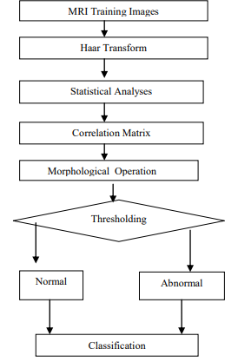

Figure 1 Block diagram of proposed system for the Feed-forward backprop neural network for Tumor Detection from Brain MRI Images. [Rani, Neha, and Sharda Vashisth. "Brain Tumor Detection and Classification with Feed Forward Back-Prop Neural Network." *arXiv preprint arXiv:1706.06411* (2017).]

The trained and tested Feed-forward backprop neural network model will be deployed in a real-life scenario for further analysis where Tumor Detection from Brain MRI Images will be leveraged for further improvement in the methodology.

**Experimental Design**

**Dataset**

The COSMIC database is established to collect, store, and display somatic mutations and related information extracted from the primary literature on human cancers as well as those identified from cancer genome projects. The COSMIC data provides a consistent view of histology and tissue ontology with the mutation information. We downloaded the data from COSMIC website on April 18, 2014. The downloaded data contained 990,529 samples, 25,660 genes, 1,292,597 coding mutations, 1,528,225 noncoding variations, and 11,330 references.

**Evaluation Measures**

Evaluation is measured in terms of SENSTIVITY, SPECIFICITY, ACCURACY, Mean Square Error performed on MRI images.

**Software and Hardware Requirements**

Python based Computer Vision and Deep Learning libraries will be exploited for the development and experimentation of the project. Tools such as Anaconda Python, and libraries such as OpenCV, Tensorflow, and Keras will be utilized for this process. Training will be conducted on NVIDIA GPUs for training the Feed-forward backprop neural network for Tumor Detection from Brain MRI Images.